MODULE 1: DATA MODELING AND INGESTION

Objective:
The objective of this module is to prepare a clean, structured, and scalable data model that supports accurate hotel revenue and occupancy analysis.

What Was Done:
- Loaded booking, customer, room, and hotel branch datasets.
- Cleaned data by handling null values, duplicates, and incorrect data types.
- Created a Star Schema data model.
- Built dimension tables: Date, Room, Customer, Hotel.
- Established relationships between fact and dimension tables.
- Derived additional columns:
- Booking Duration = Check-out Date - Check-in Date
- Room Category (Standard, Deluxe, Suite)
- Stay Type (Short Stay / Long Stay)

Formulas Used:
Booking Duration = DATEDIFF(Check-in Date, Check-out Date, DAY)

Stay Type =
IF(Booking Duration <= 2, "Short Stay", "Long Stay")

Dashboard:
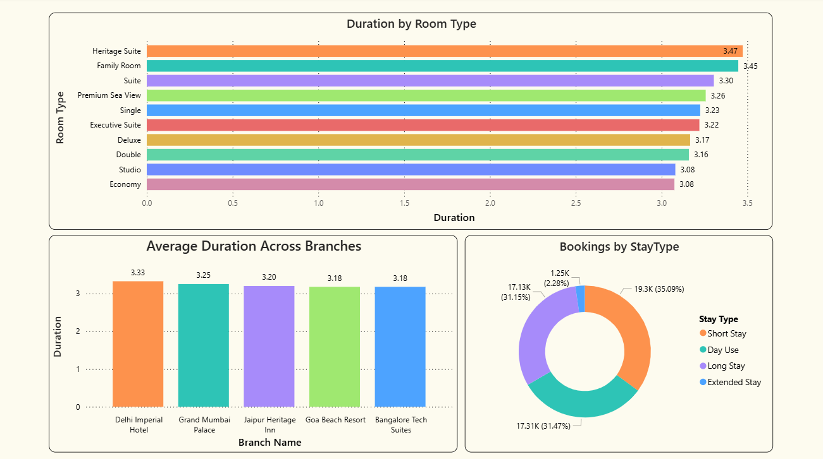

Schema:

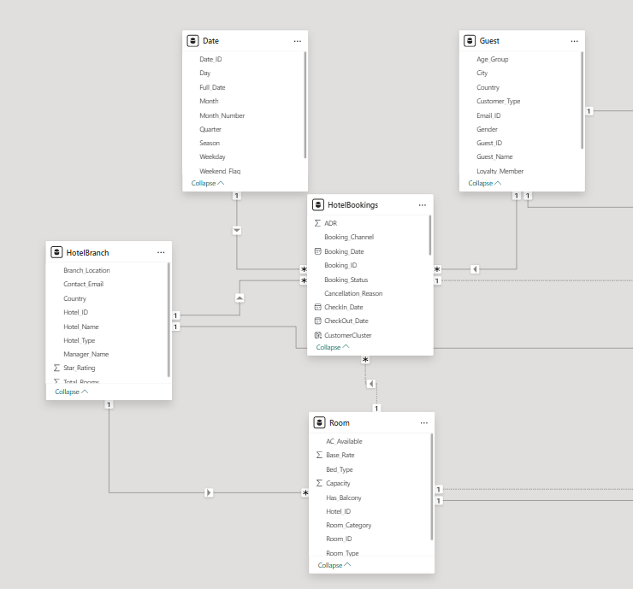

Outcome:
- Optimized data model for reporting.
- Improved performance and data consistency.
- Enabled accurate calculations across all dashboards.
- Provided a strong foundation for all analytical modules.

